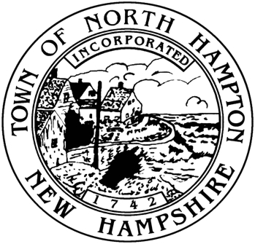

Municipal Offices

233 Atlantic Avenue

North Hampton, NH 03862

Tel: (603) 964-8087

Fax: (603) 964-1514

Jim Maggiore, Chair

Phil Wilson, Vice Chair

Larry Miller, Member

Town of North Hampton, New Hampshire

THE SELECT BOARD

PUBLIC NOTICE

It is possible that a quorum of the Select Board will be present at the Governor Dale Farm Open House on Saturday, October 19, 2013 between 3:00 and 5:00 p.m. The Governor Dale Farm is located on Post Road in North Hampton.

A quorum may be present during all or part of the afternoon.

There is no specific Select Board agenda and no minutes will be kept.